[**YouTube Video Here**](https://www.youtube.com/watch?v=RlidliEachs)

**LEVI:**

**What he likes:**

* Levi’s favorite colors are orange and green.
* He likes music except for lullabies and sad slow songs.
* He knows a lot of nursery rhymes.
* He is learning to play the xylophone.

**Current Therapies:**

* + Levi has been involved with the Arizona Early Intervention Program (AzEIP) since discharge from the hospital. He receives about two hours a week of therapy in addition to some intensive therapy sessions.
  + He was first referred to the ADAPT Shop on 8-26-2022. He has received a custom chair, and stand-up bar. His family has also been a regular user of the loan closet for gait trainers, standers, bath equipment, trikes, and the hiking cart.

Hand coordination is important (using two hands to play). He is getting better at communicating.

**Goals:**

* Motor skills to build strength and stability when using the Gait Trainer.
* Socializing with peers to increase sharing and turn-taking abilities.
* Visual perception to gain more independence in completing puzzles and games that require hand-eye coordination.
* Pre-writing to work on holding a pencil, imitating lines and tracing a name
* Emotional regulation for identifying feelings and coping with feeling sad or mad
* Potty training readiness with interoception and communication.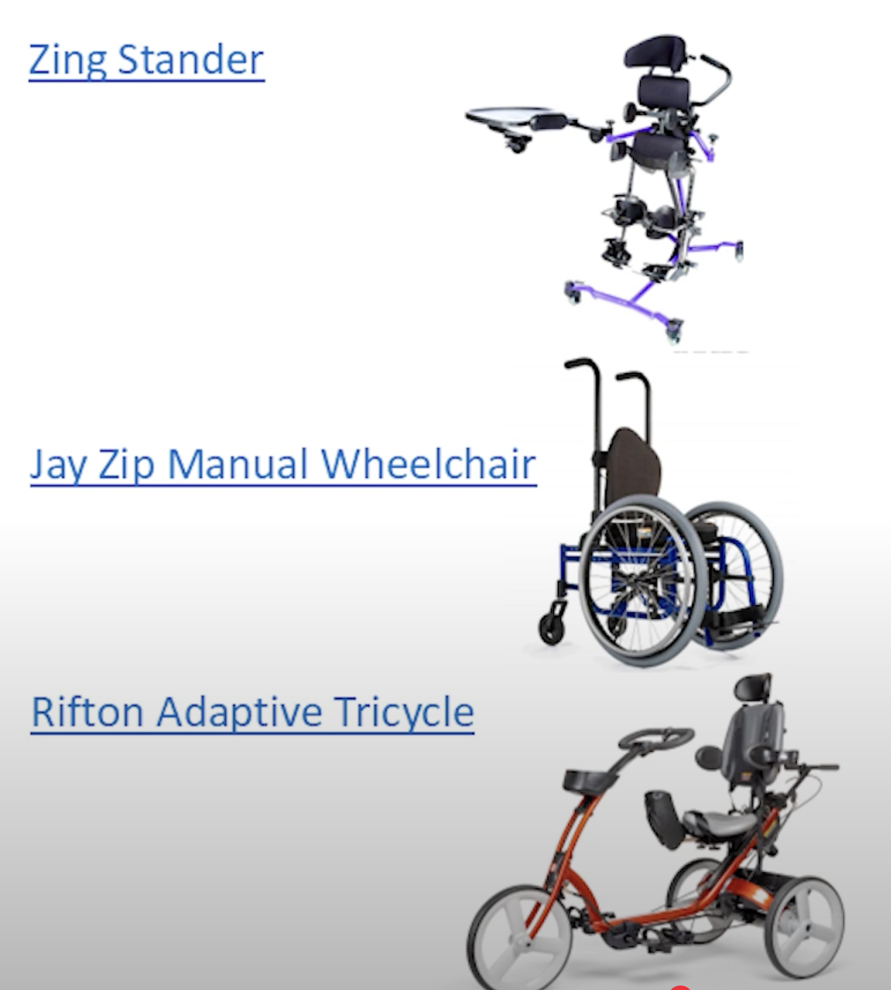

**Devices Levi currently uses:**

-Zing Stander

-Jay Zip Manual Wheelchair

-Rifton Adaptive Tricycle.

-Rifton Activity Chair

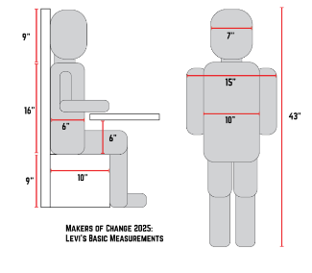(Levi Measurements)

**Challenge Statement:**

* We will invite you to learn about Levi and his family. Identify a play-based activity that he and his siblings will enjoy.
* With that activity in mind, develop an assistive device-or enhance one of his existing devices-to support Levi’s participation.
* The activity should promote shared fun, enhanced physical activity, and provide meaningful engagement for all siblings.

**Rubric Objectives:**

